

U.S. Department of Justice

ADA STANDARDS FOR ACCESSIBLE DESIGN
ADA Standards (PDF) (4.5 MB file) | ADA Standards (HTML)
As published in the Title III regulations (28 CFR Part 36, revised July 1, 1994)
issued by the Department of Justice. The ADA Standards for Accessible Design are in Appendix A of the Title III Regulations.
ADA Standards for Accessible Design (Acrobat PDF format) (4.5 MB file)
The PDF version of the ADA Standards contains the full formatted text and graphics, as published in the Code of Federal Regulations, complete with links to figures, graphics and cross-referenced sections, making it easier for users to quickly read and understand related requirements.
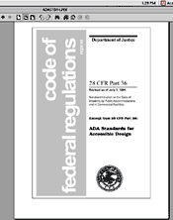 | Due to the size of the file, it may take some time to open unless a high speed internet connection is used. The file may be downloaded and saved to a computer and once this is done, it may be viewed without having to use the Internet.
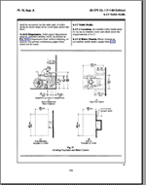 | A sample page from the PDF version of the ADA Standards showing the figures and text. Blue boxes that appear around some text are links to other figures and text.
ADA Standards for Accessible Design (HTML format)
This version of the Standards is in HTML format. It has links to the figures from the Standards but the images do not appear on the same page as the related text. The figures appear in a separate window. Text descriptions of the figures are also included.

