Appendix H: Sample Floor Plans and Regulations
The floor plans that follow demonstrate different ways that schools may utilize existing space or create new space to house their SBHC. In addition to reviewing these floor plans, see p. 3 for regulations on the layout of your SBHC, developed by the state’s Public Schools Facility Authority.

Silver City, NM SBHC Floor Plan
(SBHC converted from two large classrooms.)
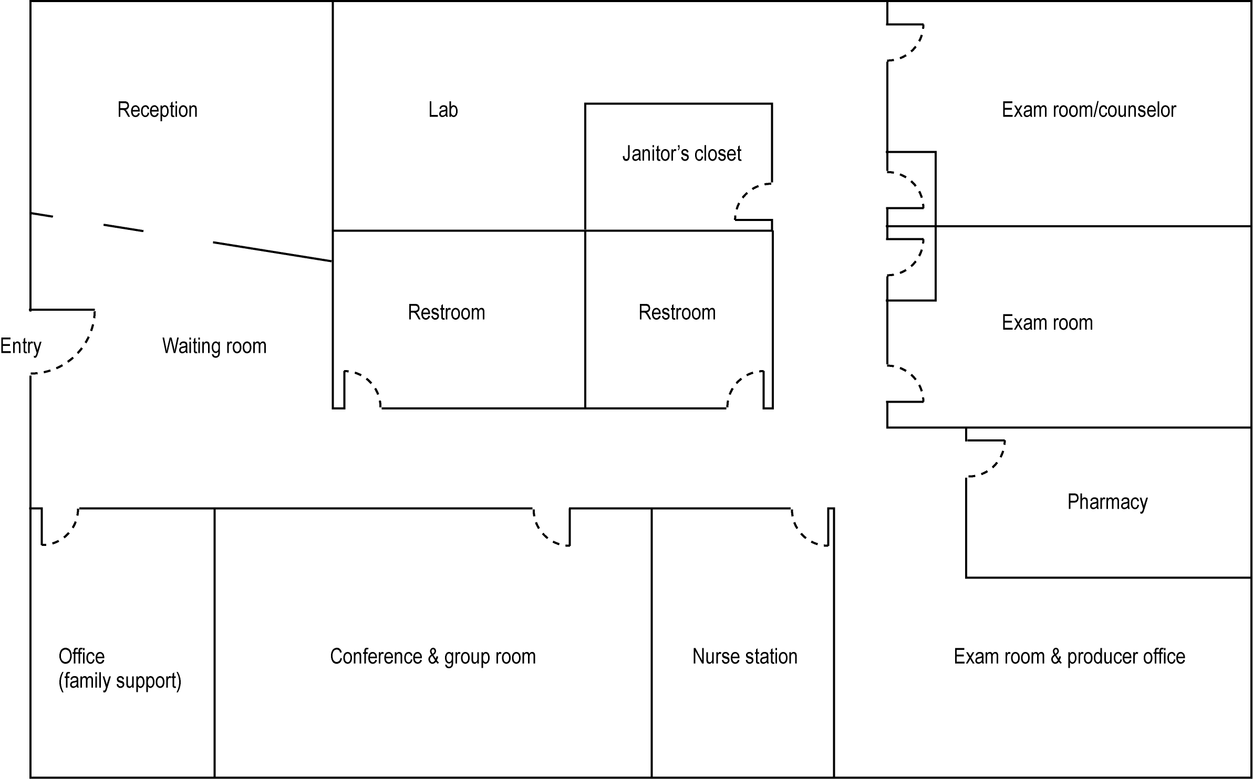

Sample Floor Plan from a Maryland SBHC
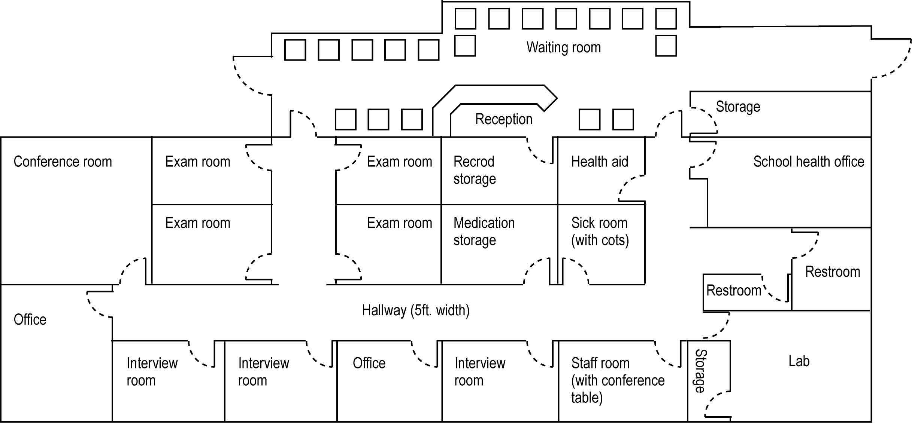

Belen High School SBHC Floor Plan
(Space created by converting a large school nurse’s office and bumping out the north and west exterior walls to add exam rooms and offices)
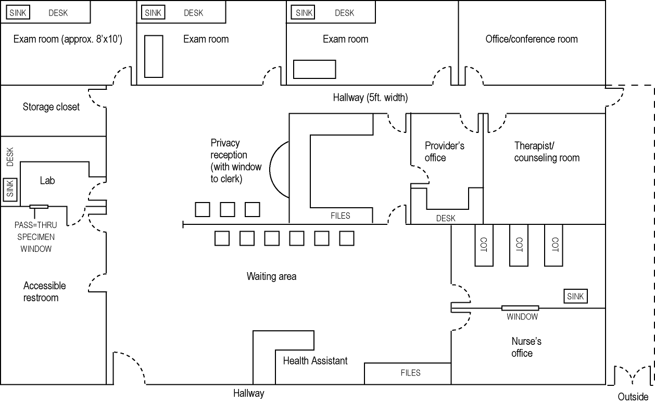

Hypothetical Floor Plan for a Free-Standing SBHC
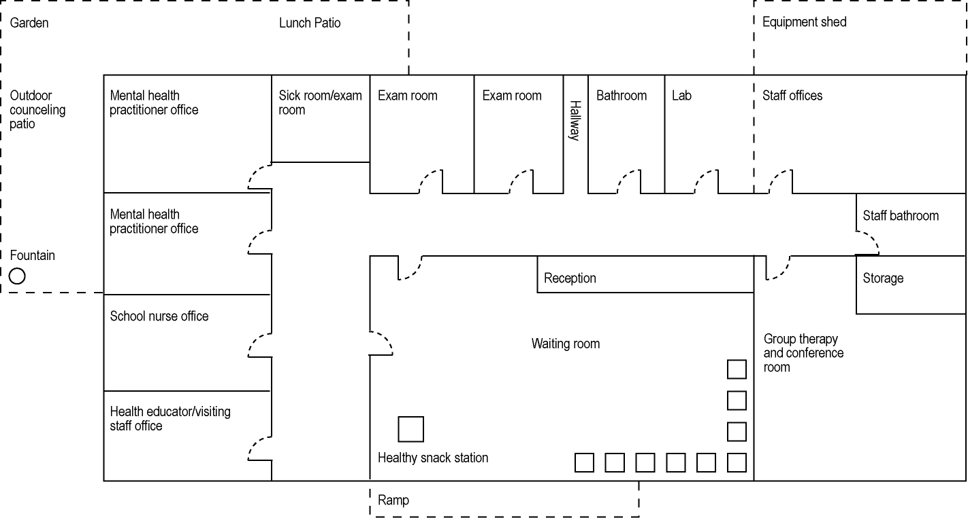

Public School Facility Authority Regulations

DRAFT ONLY (Revised: 07-08-05)

School-Based Health Center (SBHC): In addition to the general student health area, a school may plan to incorporate a separately-funded school based health center. The SBHC program is managed by the Office of School Health within the New Mexico Department of Health. Each center provides primary and behavioral health care including substance abuse treatment. Services are available to all students/clients regardless of ability to pay. The SBHC is operated by contracted health professional partners and groups who may be subject to additional accrediting requirements and regulations pertaining to facilities. Each state SBHC is classified to provide one of three levels of service (Level 1, 2 or 3) depending upon staffing capabilities and arrangements. Some SBHCs are designed to serve a client base which extends beyond the school campus and into the surrounding community. The SBHCs and schools work as cooperative partners serving the needs of the students and the community.
When planning the SBHC it is important to identify the anticipated level of the program, who will provide professional services and whether services will extend into the community. The SBHC must have qualities of privacy, safety and comfort and should be convenient to accessible student pathways, parking and emergency vehicle access. Proximity to the school nurse’s area is preferred, dependent upon that area’s location on campus. Sharing of the center’s waiting area with the general student health center waiting area may also be considered. Confidentiality in accessing SBHC services must be fostered by the location on campus and the design. The location must be inclusive without impairing the student’s perception of privacy when traveling to and visiting the center. Locating the SBHC in proximity to administration and/or security staff offices is not recommended. Interior provisions for privacy and confidentiality are necessary and can be achieved through the use of visual screening and sound transmission control. Other important considerations are security of records, medications, instruments, etc., maintaining hygiene and the proper disposal of clinical waste. The private areas of the SBHC should be designed as a suite of spaces that can be entirely secured after-hours or when not in use.
The following space types are part of the SBHC program and vary with level designations:
Waiting/Reception: A designated waiting area accommodating at least four (4) students should be provided. This area may be combined with the general waiting area for the school nurse if they are next to each other. A separate screened reception space is required to allow for confidential conversation between the SBHC receptionist and the student during admittance to the center.
Business/Receptionist Office: This office should have a window facing the general waiting area which can be secured with a roll-down security cover or grille after hours. The clinical assistant uses this office to perform receptionist duties as well as administrative support for the center. It should also have a separate window and counter for admitting students to the center in a private and confidential manner. A private telephone line, fax line, data connection and copier should be included in this area.
Coordinator’s Office: The center coordinator uses this office for administrative purposes and interviews. A telephone line and data connection should be provided.
Providers’ Office: An office with at least two (2) work stations for part-time or full-time healthcare providers is required. Furnish a private telephone line and data connection for each.
Exam Room(s): Each exam room should have a sink, exam table and soundproofing between adjacent spaces. Provide casework and a small work station with a data outlet in each room.
Behavioral Health Office/Therapy Rm.: Space is needed for a behavioral health therapist to do paperwork and provide therapy in a private setting. Provide additional seating for two persons.
Group Counseling/Conference Room: This room should accommodate 6 – 10 persons around a conference table and be soundproofed. Space is needed for meetings, group counseling, in-service training, etc.) Provide telephone and data lines. A suitable room in another part of the school may be utilized if available.
Laboratory Area: The lab area requires a sink and refrigerator for specimen storage. Provisions for safe disposal of hazardous waste are needed. Add casework for general and secure storage.
Pharmacy: A secure pharmacy space with lockable storage for medications is required. This area must conform with New Mexico Board of Pharmacy regulations.
Instrument Storage: Provide for secure storage of medical instruments (i.e. microscope, audiometer, glucometer, etc.). Such storage may be included in the lab area or other space.
Medical Records Storage: Secure and lockable storage for files may be handled in a specialized space or within another area (i.e. Business/Receptionist Office).
Toilet Room: An accessible unisex toilet room is to be provided with a double-door pass-through to the lab for urine specimen transfer. Use of the toilet room may be shared with the school nurse’s area if the two areas are adjoined and privacy within the SBHC is not compromised.
General Storage: A small general storage space is recommended with shelving.
Circulation: Corridors (5’ wide minimum) and doorways are required to accommodate movement of gurneys, stretchers, wheelchairs, etc.
DRAFT Program Spaces (Net Only)
 | Area (s.f.) | Area (s.f.) | Area (s.f.)
 | Level 1 | Level 2 | Level 3
Waiting/Reception | 120 | 120 | 120
Business/Recep Office | 100 | 100 | 100
Coordinator's Office | 100 | 100 | 100
Providers Office | 100 | 100 | 100
Exam Room
x 1 | 80
x 2 |  | 160 | 160
Behavioral Health Office/Therapy |  | 100 | 100
x 1 | 100 | 100
x 2 |  |  | 200
Group Counseling/Conf. Rm. | 120 | 120 | 120
Pharmacy Area | 50 | 50 | 50
Laboratory Area | 110 | 110 | 110
General Storage | 50 | 50 | 50
Toilet Room | 60 | 60 | 60
Medical Record Storage | 50 | 75 | 75
Total Area (s.f.): | 1040 | 1245 | 1345
Note: General circulation space and area for walls, partitions, etc. are not included in the figures above

