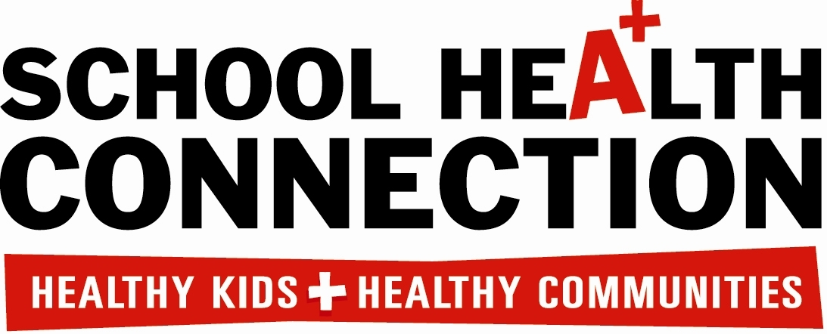
SCHOOL–BASED HEALTH CENTER PATIENT SATISFACTION SURVEY
Please give us a grade on the care we gave you today. Your answers are private and will not affect your care in any way.
DO NOT PUT YOUR NAME ON THIS SURVEY
1. Is this your FIRST visit to the School-clinic?
A. Yes B. No

2. Reason for today’s visit: (PLEASE CHECK ALL THAT APPLY)

- Sick or injured, check-up/physical F. Needed to get lab results
- Stressed out, sad, angry, nervous, etc G. Needed shots/immunizations?
- Drug or alcohol use H. Need treatment
- Toothache or tooth check up I. Other_______________________________________________________
- Needed to take medication

How did we do today on: (PLEASE CHECK ONE ANSWER FOR EACH STATEMENT BELOW)
 |  | A | B | C | D | F
 |  | GREAT | VERY GOOD | OKAY | NOT VERY GOOD | AWFUL | DOESN’T APPLY
3. | Seeing you as soon as you needed
4. | Listening to your problems
5. | Answering your questions
6. | Explaining what was making you feel bad
7. | Explaining what you needed to do to get better
8. | Being friendly and helpful
9. | Treating you with respect and sensitivity
10. | Privacy during today’s visit
11. | Give us a grade for today’s visit
12. | Circle total time spent in the center today | 5-25 minutes 26-40 minutes 41-60 minutes More than 60 minutes

13. Do you have any other needs that were not taken care of today?
A. Yes(Please Describe)_______________________________________________________________________________________
B. No

14. The best thing about today’s visit was:________________________________________________________________________
____________________________________________________________________________________________________________

15. The worst thing about today’s visit was:______________________________________________________________________ ____________________________________________________________________________________________________________

16. I would like it if the center had other services, such as:__________________________________________________________
____________________________________________________________________________________________________________

17. Would you use this School-Based Health Center again if you were feeling sick, injured or needed a physical?
A. Yes
B. No (Why not?)___________________________________

