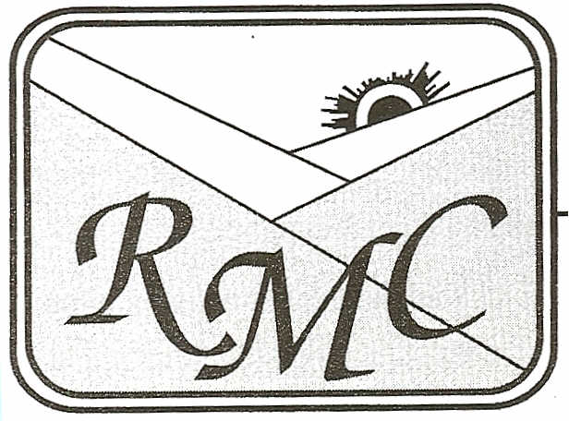

Rainelle Medical Center, Inc.
645 Kanawha Avenue· Rainelle, WV 25962-1095 Phone 304-438-6188 • Fax 304-438-7430

Dear Parent/Guardian,
Your child, , was seen in the
School-Based Health Wellness Center today for the following reason:
Instructions:

I have prescribed the following:

If you have any questions, please call 438-6188 ext. 1020 or you may call me at the numbers below.
Thank you.
Date:
R. Shaina Miller, PA-C
Wellness Center Medical Provider
Wellness Center Hours:
Greenbrier West High School- Tues afternoon and all day Thursday - 438-7893
Western Greenbrier Middle School- Tues morning and all day Friday - 392-6446 ext. 2306
Meadow Bridge High School & Elementary School- Mon & Wed all day - 484-7571

Meadow Bridge Clinic· P.O. Box 120· Meadow Bridge, WV 25976·304-484-7755

